1. Admin Display Images

Get images from <proxy server>/public/banner-files

Send files to /api/v1/uploads/banner-files (PUT)

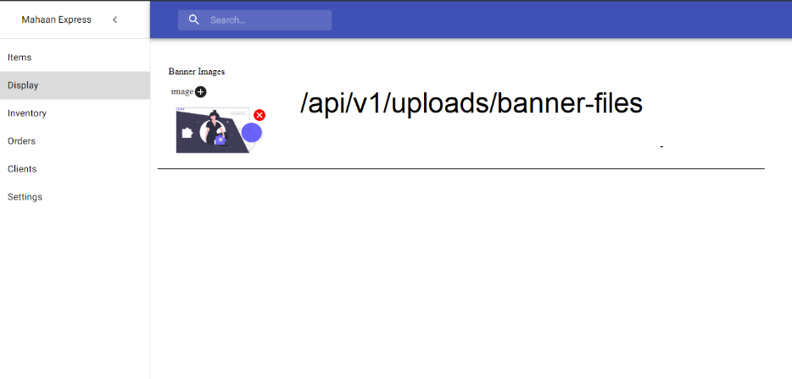

1. Style frontend/admin/src/components/DynamicInput
2. Admin Display Favorites, Best Value, Featured Default Lists API patch
3. Add a “Close“ text-button to the end of snackbar and hide the snackbar even if the user clicks anywhere in snackbar. It’s annoying if it sticks and user cannot click beneath it.

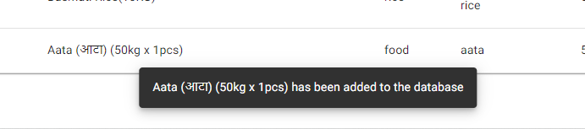

1. Cursor pointer in every row and highlight the row with #eee on row hover. User will have better sight and follow on same information of a particular row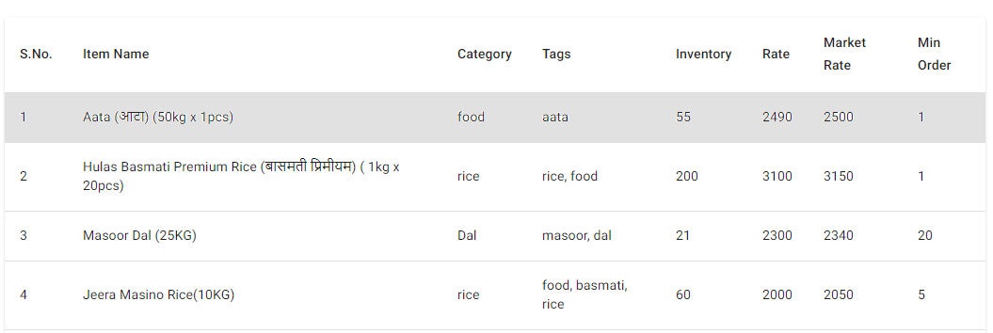
2. Instruction for Tags, placeholder to tell user about how to write there. “E.g.: dal, chamal”

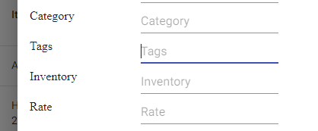

1. Change description to textarea not input

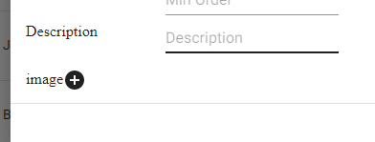

1. Change width of input to 100% with smaller similar padding as of left keys in all forms.
2. Also change “SAVE CHANGES” position to left align in all forms

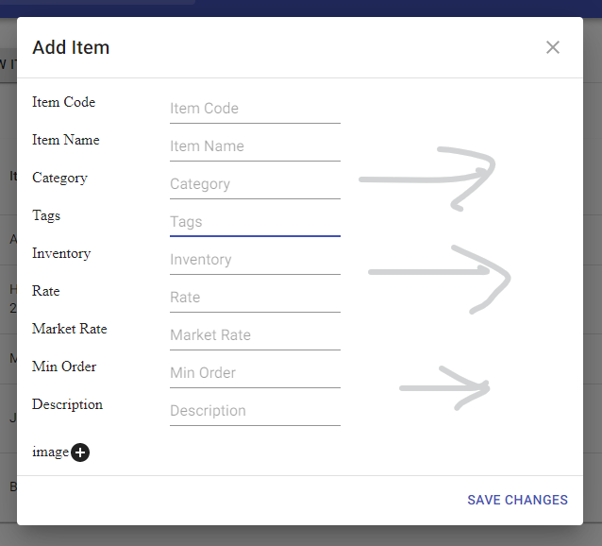

1. Inventory; Follow this series here: Subtract, Input, Add

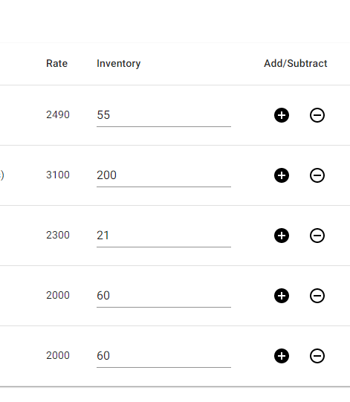

1. Orders; create new fields for nested object

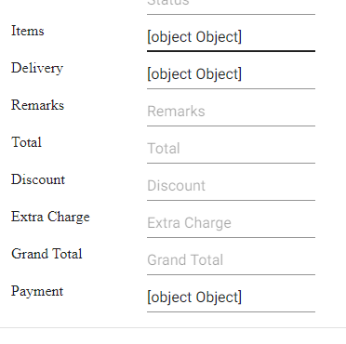

1. Sans serif sont is still not showing anywhere

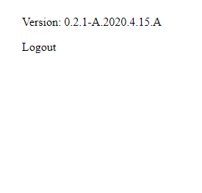

1. Make this margin of equal height. Use bottom width in top too.

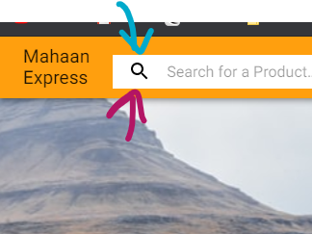

1. Change in Search design see users.xd

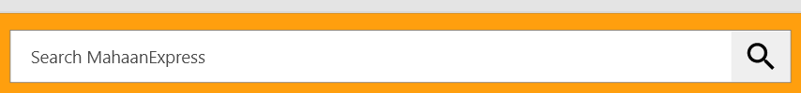

1. Align the search bar to center… let the both ends be similar in width. Also, align “Mahaan Express” logo to the center of its container

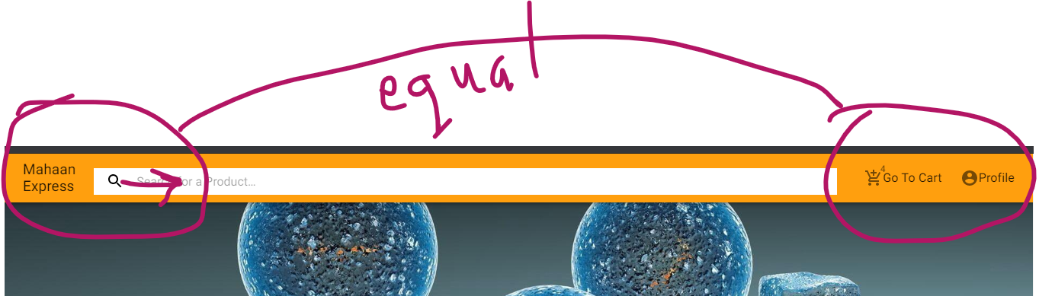

1. Use normal cart icon



1. Make these icon buttons bigger, here and in all the horizontal sliders like “Featured”, “Best values”,…

user should have maximum accessibility



1. These product cards are big. Let 6 of them fit in a single row at a view

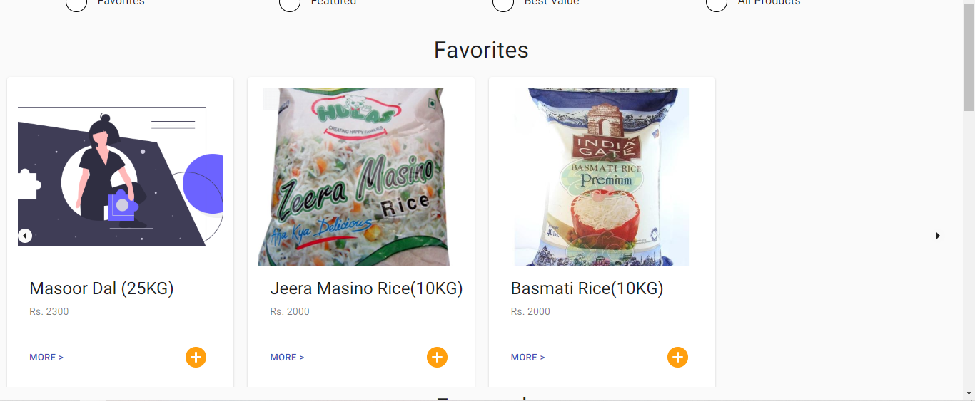

1. Row keeps sliding even if no items left

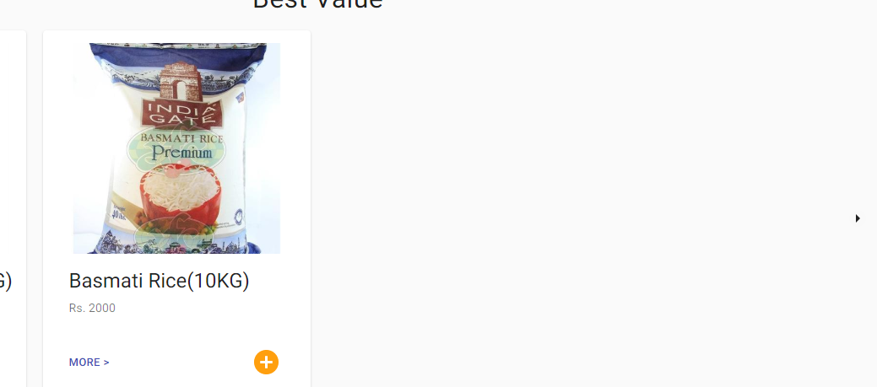

1. Here’s our big problem. Look at how the top header and our body scales on zooming out.

Look at *https://daraz.com.np* at 50% zoom and even [*https://about.junee.co*](https://about.junee.co). You can achieve this by

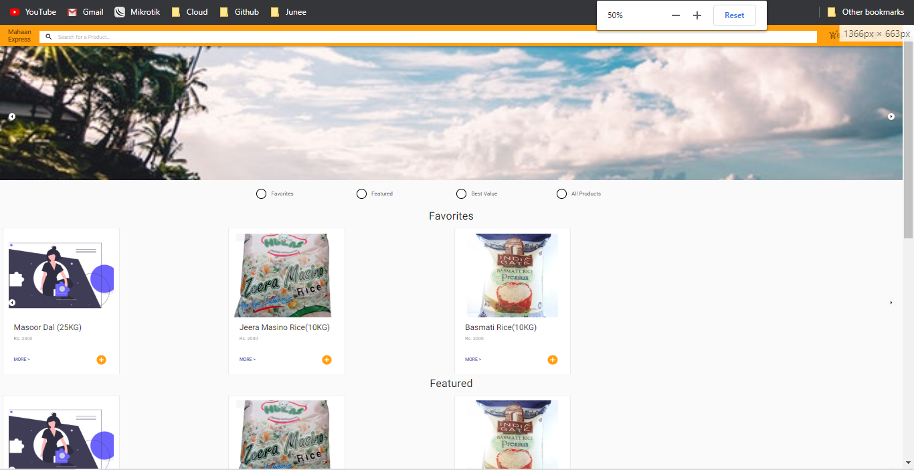

1. Title Font is comparatively bigger. Make the text wrap to two rows with at least 6 words with average of 7 letters just like the right image

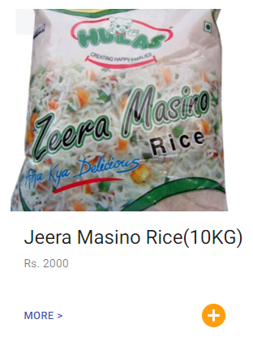

1. Adding … at the end if word count exceed 6*7 = 42

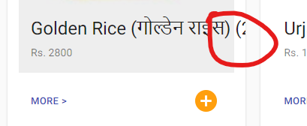

1. Add load more at bottom of item entries similar to this



1. Small padding here

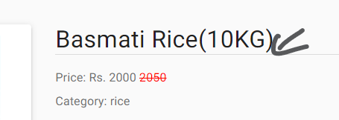

1. Margin

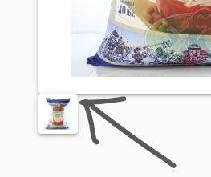

1. Gotcha here

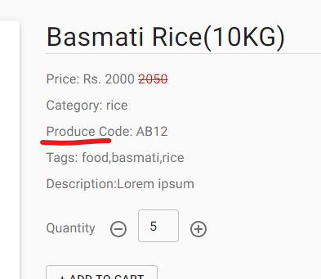

1. Let this always stick to bottom even if content isn’t there. Look at *https://junee.co/* footer while zooming in and out. The footer always remain **at least a scroll** below the page. That’s why it’s a footer.

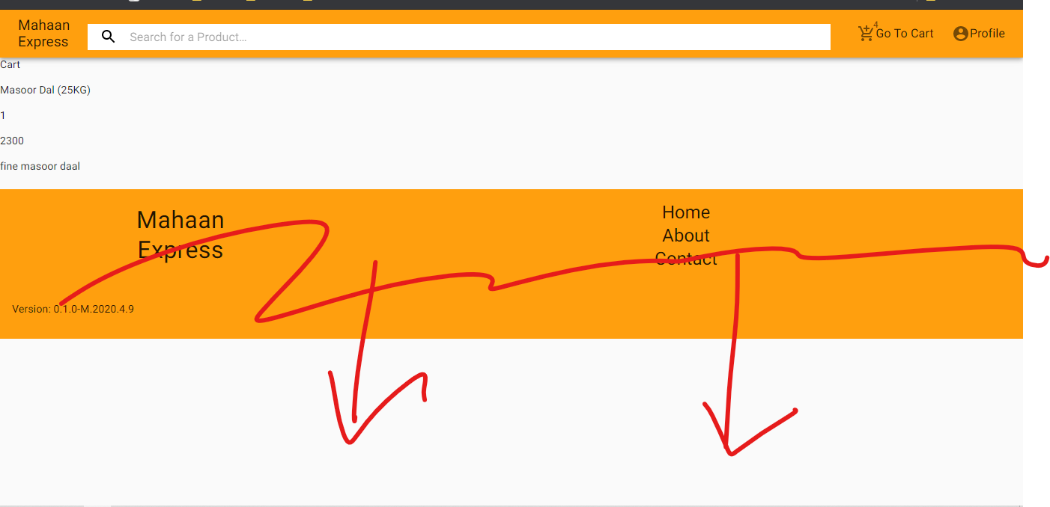

1. Let images fit inside a container, which means occupy the container with whichever among height or width is larger. But show the full image, fill the remaining blank with white background.

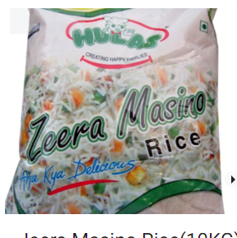

1. Mobile view, Make these two rows of same width. Match search width with upper row.

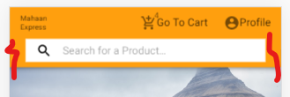

1. All other rows like ‘featured’, ‘best values’ goes horizontal and has sideways arrow except All Categories

All Categories goes only vertically.

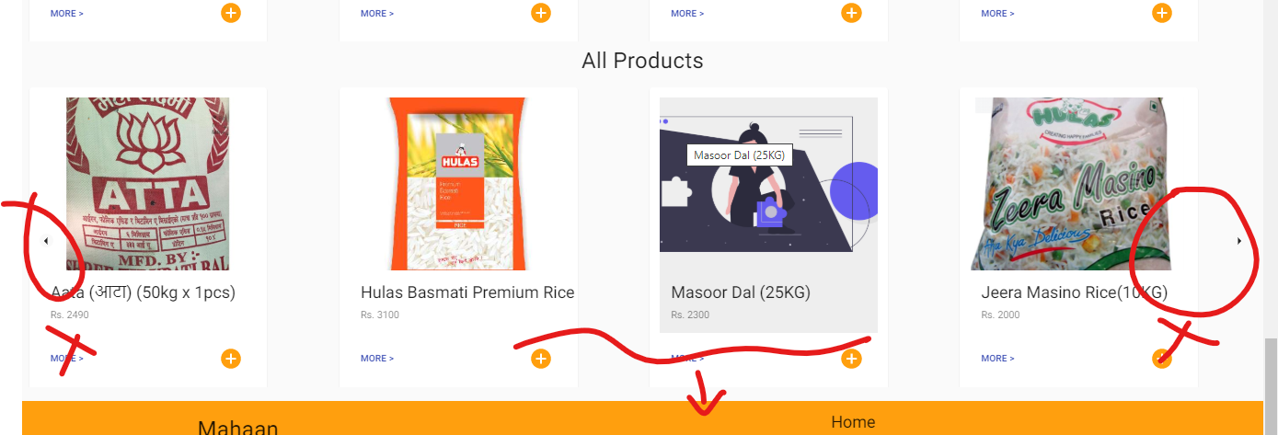

1. Mind a minor design feature in users.xd file. Let the horizontal slidable rows show a small portion of the next element so that user knows that there’s more and they can initiate action. But All Products flows vertically so, no need to do any tweaks.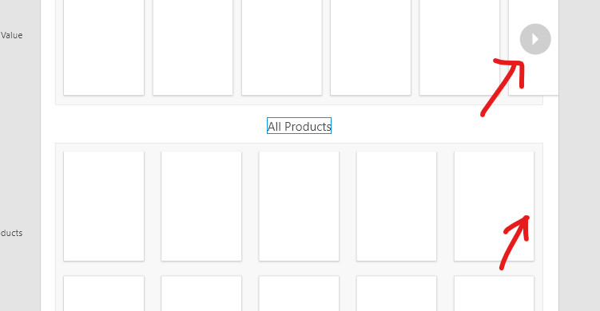

……..

You’ll see the best example done by a giant company Facebook including Instagram to hook users too. Hitting two birds with a stone. First letting users initiate a tiniest action to keep them scrolling. You’ll see this pattern in most of the websites if the designers have minded keeping this “design hook”. Even in new Aero design. Same for Instagram app.

